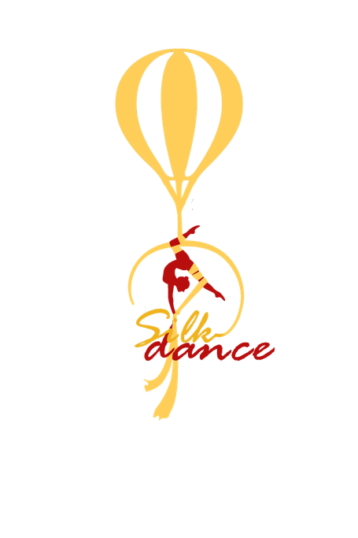

**SELF-DECLARATION**

NAME ....................................................................................................,

PLACE AND DATE OF BIRTH: ........................................................................................,

ID OR PASSPORT NUMBER: .............................................................................................

I consent ........................................................(name),

..........................................................(place and date of birth) taking part in VI. SilkDance International Aerial Competition.

I am prepared, healthy and being in good condition to compete.

• I understand that everybody competes at their own risks.

• I understand that the competition includes a photography and film component in which I will be both photographed and videoed. I understand that these images will be part of advertising and press related.

• I relieve the organizer of the event called the NEW STEP FITNESS AND DANCE STUDIO from any responsibility in case of falls of the tool attributable to my errors in execution, distraction or similar.

• With this release the organizers are released from any direct or indirect liability related to the damage to my person during my race performance.

DATE:

.......................................................................................................................

SIGNITURE