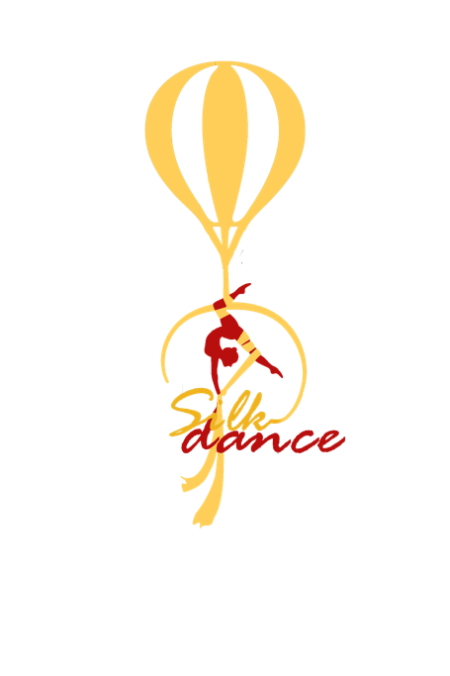

**SELF-DECLARATION**

NAME ....................................................................................................,

PLACE AND DATE OF BIRTH: ........................................................................................,

ID OR PASSPORT NUMBER: .............................................................................................

I consent to my son/daughter........................................................(name),

..........................................................(place and date of birth) taking part in VI. SilkDance International Aerial Competition.

He/She is prepared, healthy and being in good condition to compete.

• I understand that everybody competes at their own risks.

• My son/daughter will obey the rules of the competition.

• I understand that the competition includes a photography and film component in which my child will be both photographed and videoed. I understand that these images will be part of advertising and press related.

• I relieve the organizer of the event called the NEW STEP FITNESS AND DANCE STUDIO from any responsibility in case of falls of the tool attributable to my errors in execution, distraction or similar.

• With this release the organizers are released from any direct or indirect liability related to the damage to my son/daughter during his/her race performance.

DATE:

.......................................................................................................................

SIGNITURE OF THE PARENT